A FRAGMENT OF A ROMAN MILITARY DIPLOMA DISCOVERED IN THE VICINITY OF MICOȘLACA (MIKLÓSLAKA, OCNA MUREȘ CITY, ALBA COUNTY)
Marius-Mihai Ciută
Lucian Blaga University Sibiu
mariusciuta@yaho.com

Florian Matei-Popescu
Vasile Pârvan Institute of Archaeology
florian.matei@gmail.com

Abstract: A fragment of a Roman military diploma, discovered in the vicinity of the former village of Micoșlaca, nowadays part of the city of Ocna Mureș, can be here published. Although, the fragment has been discovered by the mean of the metal detecting, the founder fully collaborated with the heritage police officers of the Alba County. The exact location was thus thoroughly investigated, and all the relevant topographical and archaeological context of the discovery has been clarified. The fragment turns out to be another copy of the imperial constitution issued on the 8th of July, 158 for the former auxiliary soldiers of the Dacia superior province, constitution already known through the almost complete military diploma discovered in 1886 at Cristești (nowadays part of the city of Târgu-Mureș, Mureș County). Taking into account the place of the discovery, it is likely that the copy had been given to a former horseman of the ala I Batavorum milliaria, accommodated within the large Războieni-Cetate Roman fort.
Keywords: Dacia superior, Roman military diploma, metal detecting, Micoșlaca-Ocna Mureș, Războieni-Cetate.

Introduction
The range of publications related to the ever-grown phenomenon of metal detecting in the field of archaeology has seen a special dynamic in Romania in the past years. It is the natural consequence of several factors, among which, first of all, we have to mention the lack of the legal regulation in this field, after more than twenty years since the publication of the main normative act that addresses, tangentially, this issue. Unfortunately, the initial form of the mentioned act, which should have clarified, at least in principle, the proper conduct of any metal detector owner in the situation in which they would have discovered contexts with archaeological deposits, respectively goods likely to belong to the national cultural heritage, does not regulate, in fact, this activity!
Paradoxically, all the other subsequent attempts to correct and to define the concept of chance discovery - and thereby limiting the interest of achieving archaeological finds motivated by the financial reward-namely by imposing more efficient instruments for monitoring the activity of the detectorists, by the presence of an archaeologist at their exits in the field, etc.; they ended up having no concrete purpose in the field of the legal regulation. Thus, the needed preventive measures to eliminate the potentially serious consequences generated by the identification of archaeological contexts by persons who do not have any training in the field, could not be taken.
The procedure for the remittance of randomly discovered cultural property does not benefit from a unitary, coherent treatment in the text of the law, given that Government Emergency Ordinance 43/2000 enters into obvious legal conflict with the law 182/2000, on the procedure of the handing over of movable cultural goods. That is why, in each different county of Romania, the procedure differs, depending on the particularities of the public institutions mentioned in the normative acts, a situation that highlights the law lacking its unitary enforcement character! There are counties where the artefacts are handed over to the county directorates for Culture and Heritage and counties where the items are handed over to the mayors of the administrative territorial unit, but also the situation, not mentioned in the law, where the pieces are handed directly over to museums.
The recent phenomenon of the virtually “explosion” of the number of metal detector owners, impossible to predict almost twenty years ago, finds the archaeological heritage in the face of the completely unfortunate situation in which the management conducted by the authorities with responsibilities in the field of supervising the activity declared by metal detector owners as recreational, to become, at best, a utopia. More often than not, the detectorists, even if they are well-intentioned, sincerely want to comply with the law and do not pursue financial rewards, are faced with unforeseen situations because the sources of information are precarious (see National Archaeological Repertory) or completely missing!
The Findspot
The fragment of the Roman military diploma was discovered by a metal detector owner, a local from Ocna Mureș city. Fortunately, he insisted on taking the legal steps as soon as he uncovered it. The fragment was discovered on the 26th of March, 2022, into an area which, according to the previous existing records, was not previously enlisted as an archaeological site or protected area of an archaeological site (Fig. 1). Since the mayor of the city was not available on the 28th of March, 2022, the person got in touch with the police officer specialized in the field of protecting the national cultural heritage, who decided to take the artefact after clarifying the exact circumstances of its discovery, in order to be handed over to an authorized museum.
To clarify the situation, after carrying out the procedures related to the handing over of the artefact (the minutes of delivery and reception of the piece, specifying the topographic coordinates of the discovery), the next day the trip to the field was organized, together with the owner of the metal detector, to spot the exact location of the discovery. At the same time, the bibliographic documentation was carried out, and the settlement related to the discovery benefited from few archaeological references. Micoșlaca (Miklóslaka) settlement, currently belongs to Ocna Mureș city, previously belonging to Cisteiul de Mureș commune, is located at a distance of approx. 3 km South-West of Ocna Mureș, on the bank of Mureș, spread on the first and second terraces of the river, on its left, on the southern side as the river flows. (Fig. 1-3)
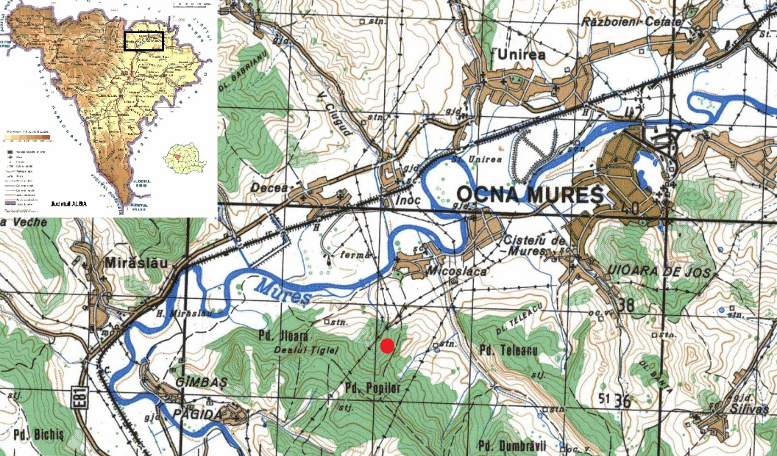
Fig. 1. The Mureș River between Războieni and Păgida, with the exact location (red dot) of the findspot (source: MApN L-34-60, Seria M 605)

South of the settlement, a well-defined plateau, called La Podaș, is located with an average elevation of about 280 m, limited to the East by the Cistei creek and to the west by a seasonal torrent originating in Pădurea Dosu, on the hill that dominates, from above, the entire plateau. (Fig. 2). Iron Age settlements (La Tène I) and Roman ones (a large Roman settlement) are identified on this plateau and are reported as such by the archaeological gazetteer of the Alba County. The area of the site was surveyed in 1963, and the research was resumed in 1987-1988 by Ion Mitrofan, but the results were never published.

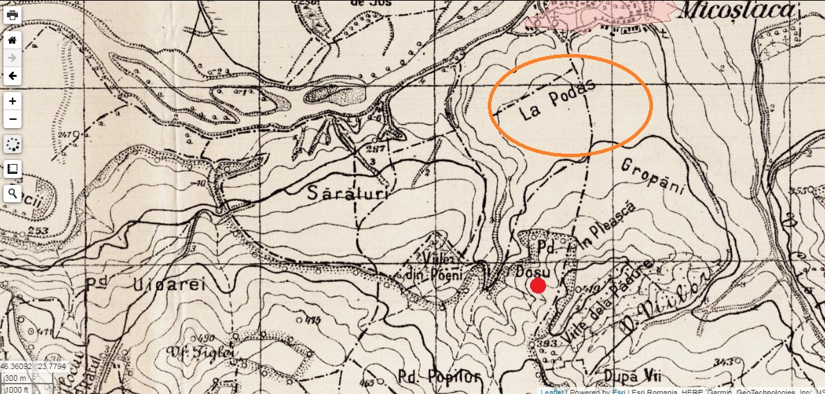
Fig. 2. Topographical detail of the area of the findspot with the given the place names. In the area named “La Podaș”, the surface archaeological researches led to the identification of a Roman settlement (source: https://map.cimec.ro/Mapserver/)

The La Podaș plateau, nowadays entirely covered by crops, is crossed right in the middle, from the North to the South, by a country road, which later goes on a relatively steep slope, towards a hill, partially covered by forest (Pădurea Dosu) in its upper zone, that dominates the entire area (Fig. 2). This road appears on the old Austrian maps and it goes through Pădurea Popilor to the nearest peak (Vârful Țiglei), and from there, following the watershed, having the character of a ridge road, goes parallel to the Mureș river to the South-West, towards Păgida-Ciumbrud, in the front of the city of Aiud (Fig. 2-3). Practically, it is the shortest and most convenient access route from the Ocna Mureș area to Aiud, before the modern road network. It is highly probable that this road could have been ancient, being used at least since the Roman period (Fig. 9).
At the entrance to the Pădurea Dosu edge, it is worth noting the excellent visibility over the entire Mureș valley, from Războieni-Cetate to Decea Mureșului, which certainly improves on the tops of the hills (Fig. 4-5). From the point of entry into the forest, at a distance of approx. 350 meters, the main road has a deviation to the West, abandoned, most likely used when the main road is harder to pass due to rains, due to the rather sharp inclined slope (Fig. 5). This secondary road has a length of approx. 200 meters, at the south end it reunited the main one (Fig. 2-4, 6).

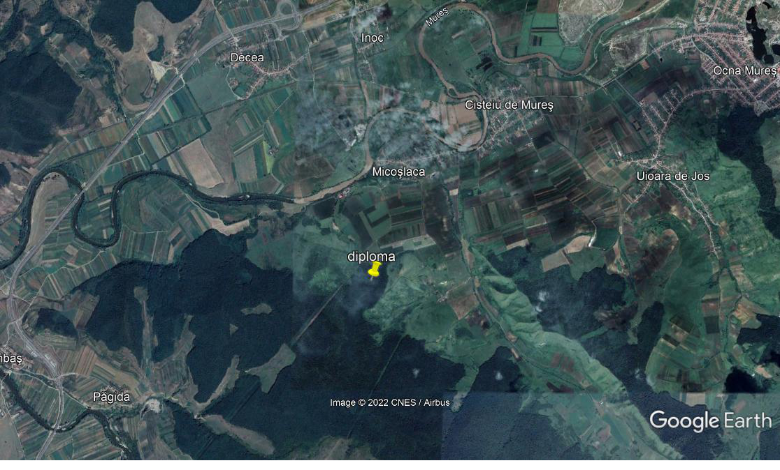
Fig. 3. Satellite map of the area where Mureș river bypasses the hills between Micoșlaca and Păgida – Aiud. (source: Google Earth)

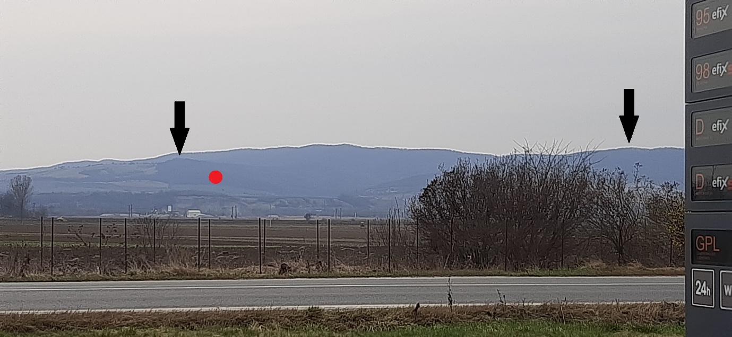
Fig. 4. View of the findspot from the North (the Decea Mureșului gas station on the route E81) (red dot – the findspot; black arrow 1: “Viile de la pădure” peak; arrow 2: “Țiglei” peak).

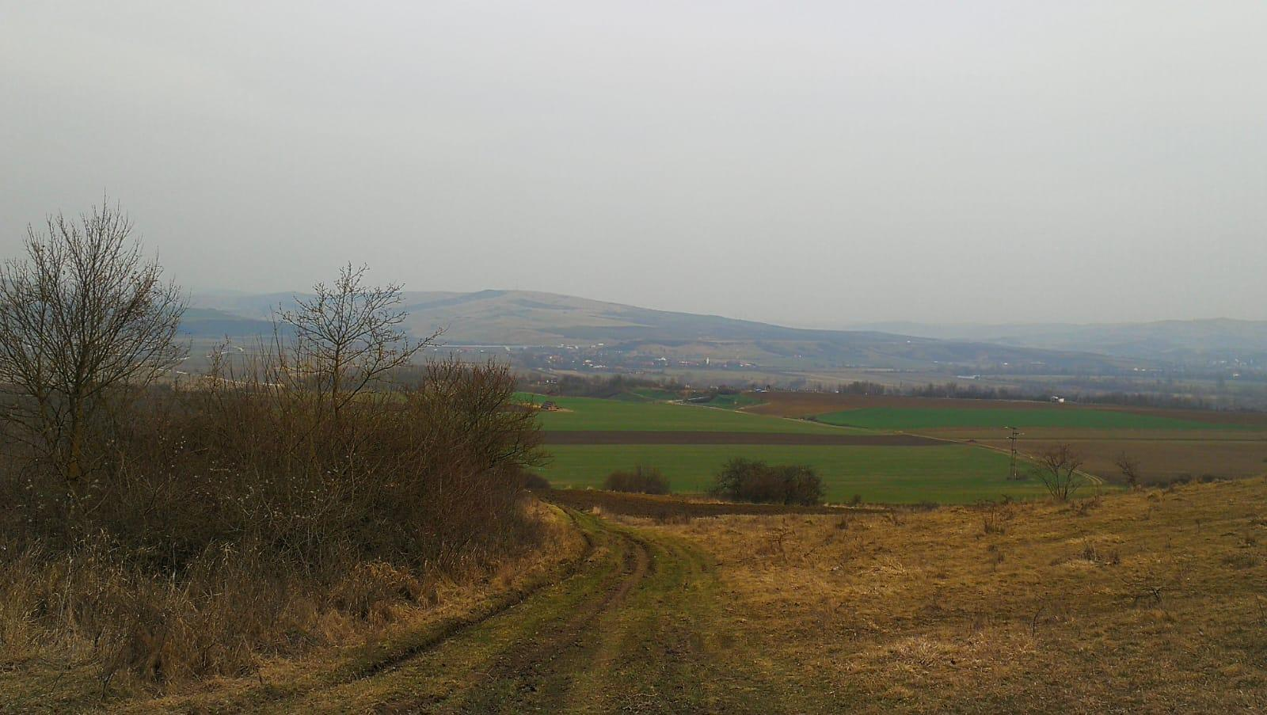
Fig. 5. View to the North, from the entrance in the Dosu forest, near the findspot. In the distant plane the Decea Mureșului Village.

To the West of this road, the terrain is heavily broken by the torrents that created heavily profiled ruts, which head, to the North, towards the Mureș river, by means of a unique torrent delimited to the West by the area with the place name: Sărături (Fig. 2, 6).
It is on this secondary road, entirely covered by a thick layer of leaves, that after scanning and receiving a signal, the founder indicated the place where he removed this layer, discovering at a very shallow depth (3-5 cm), practically semi-buried, the copper fragment. Continued detections in the secondary road segment, which has the groove appearance of an abandoned torrent (with a “U” shaped profile), did not lead to the discovery of other similar fragments (Fig. 6). The metal piece was in a good state of conservation, with the edges torn from age. The ancient patina was unaltered, and the surfaces were brief cleaning by the discoverer with water. No signs of recent breakage were noticed (Fig. 7).

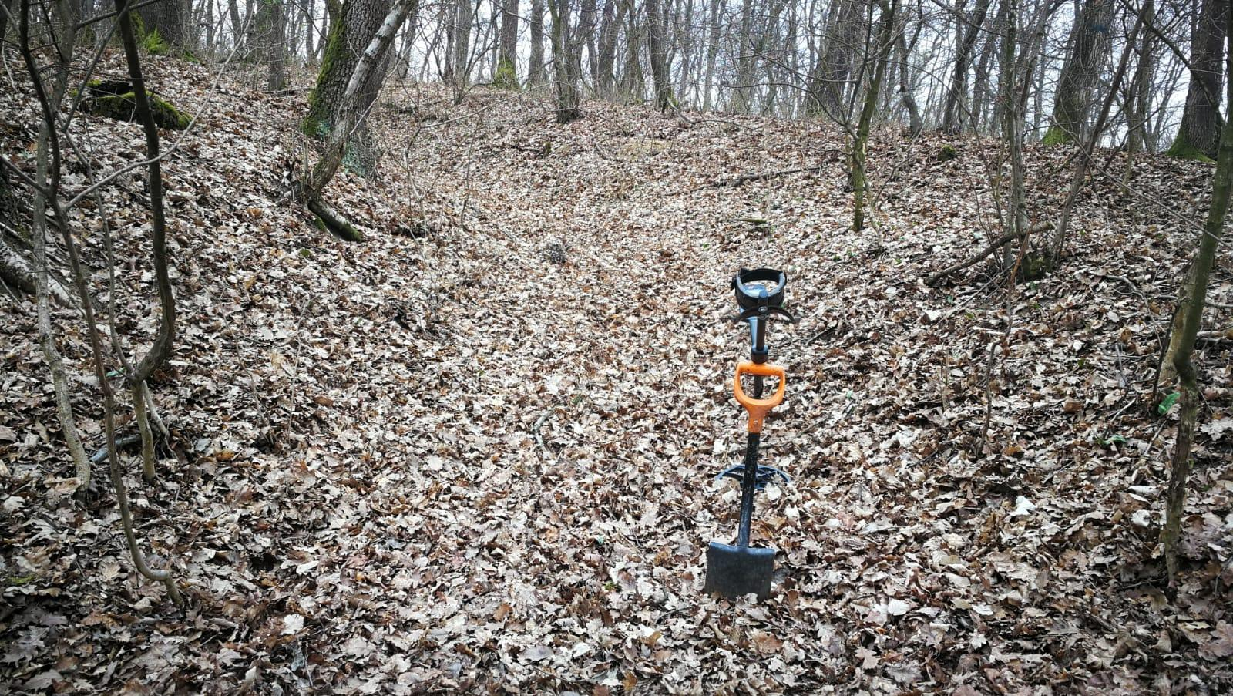
Fig. 6. Detail of the exact spot where the military diploma was discovered, viewed from North (photo taken during the documentation trip on the 29th of March, 2022)
The documentation of the nearest hilltop, located at a distance of 150 meters to the southeast of the place of discovery (the peak Viile de la Pădure, alt. 393m), did not show any sign of human intervention or other type of archaeological materials at the surface. The road then stretches West-Southwest, through Pădurea Popilor, to another taller peak (Vârful Țiglei, alt. 490 m) now forested, but, on older maps, a rectangular feature is depicted, from where one can see the southern slopes of the hills that surveys the entire area located in the large loop made by the Mureș riverbed (Fig. 2, 6). As a working hypothesis, it is possible that, due to the location and the excellent view, covering almost 360 degrees of the sector, from Războieni-Cetate and Aiud (and further to Sâncrai and Teiuș) a possible watch tower could have been located there during the Roman period. The place name Salinae have been located in the area of Uioara and Ocna Mureș, on the road between Aiud and Turda (Potaissa), on the right side of the Mureș river, which proves that the salt exploitation had been already into place even before the Roman conquest. Exactly on the opposite side of the river bank the large Războieni-Cetate Roman fort is located, which could give us some clues related to our fragment (Fig. 1, 3, 5).

The military Diploma
Fragment of the middle top of tabella I of an auxiliary diploma. Height: 3,3 cm; width: 2,63 cm; thickness: 0,12 cm. Two framing lines are visible on the outer face, of which the upper framing line is only partially visible (Fig. 7-8). It has an irregular shape, close to an erratic pentagon.

extrinsecus
[IMP CAES DIVI] HADRIAN[I F DIVI TRAIA] 29
[NI PARTHICI] NEP DIVI NER[VAE PRONEP] 29
[T AELIVS HADRIAN]VS ANTONIN[VS AVG PIVS] 30
[PONT MAX TR POT] XXI IMP II [COS IV P P] 27
[EQVIT ET PEDIT QVI M]ILIT IN AL[IS III] 29
[QVAE APPEL I BATAV∞ E]T I HIS[P CAMPAG] 28
[ET I GALL ET BOSPOR E]T COH [I THRAC SAG] 29 etc.

intus
ET S[VNT SVB STATIO PRISCO LEG XXV STIP] 28
EM DIM [HON MISS QVOR NOM SVB] 22
SCR SV[NT CIV ROM QVI EOR NON HAB] 26 etc.

The emperor Antoninus Pius held his 21st tribunicia potestas between the 10th of December 157 and the 9th of December 158, therefore the diploma was copied after an imperial constitution issued precisely in that period, highly probable in AD 158. Only the name of one unit is preserved, among the alae, i. e. I Hispanorum. Taking into account the place of the discovery it is almost sure that the unit should be one of the units located in Dacia superior. The only ala that bore this name in the province was ala I Hispanorum Campagonum, accommodated in the large fort of Micia (Vețel, Hunedoara County), together with cohors II Flavia Commagenorum and the numerus Maurorum Miciensium.
a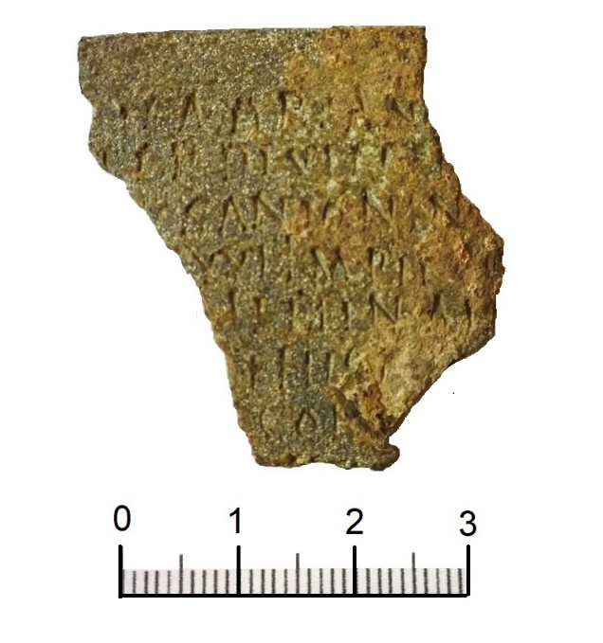 b 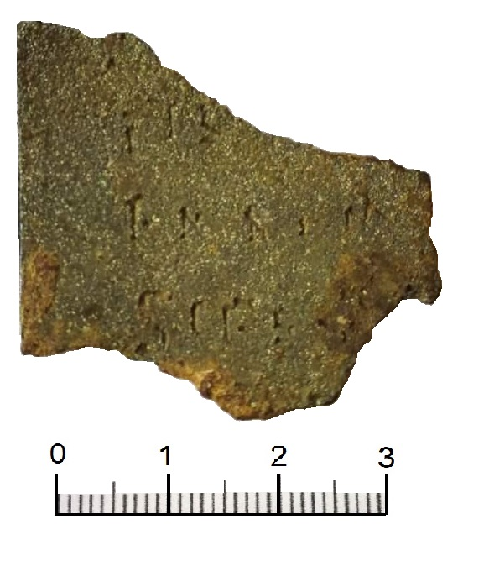
Fig. 7. The military diploma discovered at Micoșlaca (Miklóslaka). |Extrinsecus (a) and intus (b)

In fact, the fragment could belong to another copy of the imperial constitution issued on the 8th of July, 158, already attested by a fully preserved diploma, discovered at Cristești (Mureș county) in 1886. The restored text of our fragment follows the entirely preserved text of that diploma. This second copy attests that a dilectus for the units of Dacia superior and, probably, for the units belonging to the other two Dacian provinces was carried out in the AD 133. In that year, many soldiers recruited in around AD 108, after the making of the province, were released from duty as some military diplomas attests. Since the diploma was found not far from Războieni-Cetate, probably Ad Batavos during the Roman period, it is possible that the copy would have been given to a former horseman of the ala I Batavorum milliaria. The governor of the province of Dacia superior was M. Statius Priscus Licinius Italicus, attested in AD 156-158 (in AD 158 attested also as consul designatus), before becoming consul ordinarius in 1st of January, 159.

a 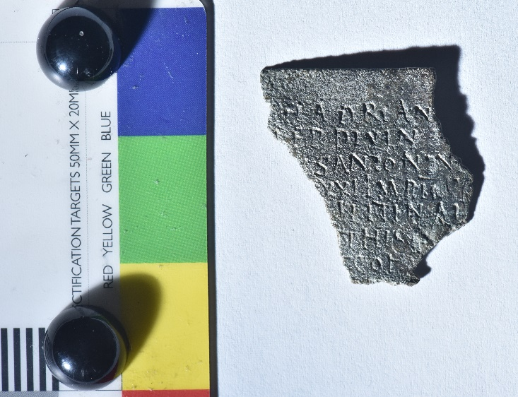 b 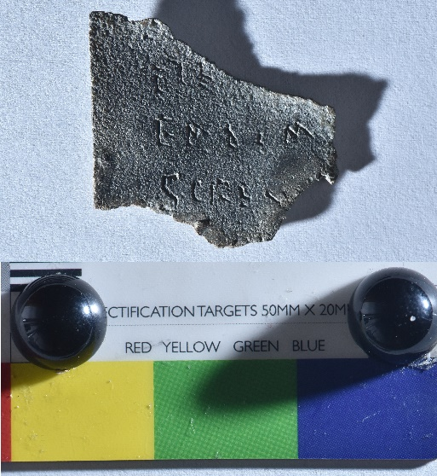
c 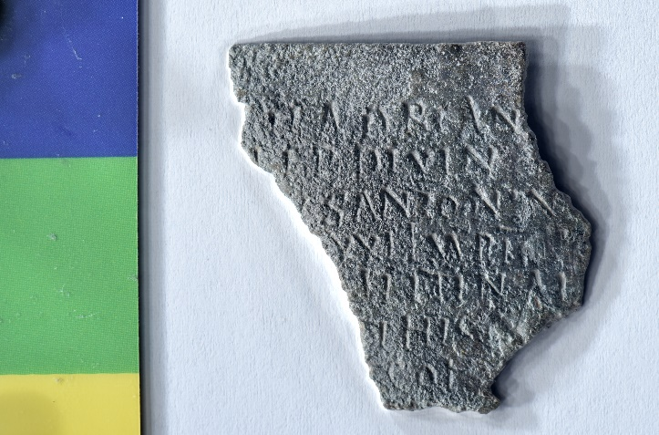 d. 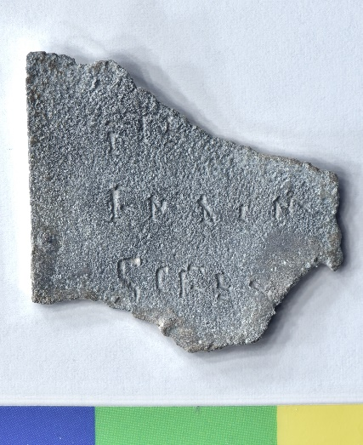
Fig. 8. The military diploma discovered at Micoșlaca (Miklóslaka). |Extrinsecus (a, c) and intus (b, d) (credits: C. Șuteu)

The grant was given to the horsemen of all of the three alae in the province: I Batavorum milliaria, I Hispanorum Campagonum and I Gallorum et Bosporanum; three cohortes: I Thracum sagittaria, IV Hispanorum and I Augusta Ituraeorum; and to vexillarii from Africa and Mauretania Caesariensis provinces, who came in Dacia superior with the Mauri gentiles around AD 142. They were in fact, horsemen taken from different units from both provinces, or former members of the vexillationes sent from the European provinces to North Africa in the context of the Moorish war, and dispatched thereafter to Dacia superior together with the recruited Mauri, who built some numeri Maurorum, attested in various parts of the province. The listed units were not of course all the auxiliary units deployed in the Dacia superior province. Some other formers soldiers had been released more than one year before, on the 13th of December, 156, from the same three alae and from ten cohortes, among which four remains unknown: I Vindelicorum milliaria, II Flavia Commagenorum, I Ubiorum, I Thracum sagittaria, V Gallorum Dacica, I Augusta Ituraeorum; and the pedites singulares Britanniciani.
Based on the diploma from Cristești the text of this diploma and of the imperial constitution can be reconstructed as follows:
[Imp(erator) Caes(ar), divi] Hadrian[i f(ilius), divi Traiani Parthici] nep(os), divi Ner[vae pronep(os), T(itus) Aelius Hadrian]us Antonin[us Aug(ustus) Pius, pont(ifex) max(imus), tr(ibunicia) pot(estate)] XXI, imp(erator) II, [co(n)s(ul) IV, p(ater) p(atriae)]
[equit(ibus) et pedit(ibus) qui m]ilit(averunt) in al[is III] quae appel(lantur) I Batav(orum) ∞ e]t I His[p(anorum) Campag(onum) [et I Gall(orum) et Bospor(anorum e]t coh(ortibus) [I Thrac(um) sag(ittaria) et IV Hisp(anorum) et I Aug(usta) Itur(aeorum) et vexil(larii) Afric(ae) et Mauret(aniae) Caes(ariensis) qui sunt cum Mauris gentilib(us) in Dacia super(iore)] et s[unt sub Statio Prisco leg(ato) quinq(ue) et vigint(i) stip(endiis)] em(eritis) dim(issis) [honesta mission(e) quor(um) nomin(a) sub]scr(ipta) su[nt civit(atem) Roman(am) qui eor(um) non haber(ent) dedi et conub(ium) cum uxoribus quas tunc habuis(sent) cum est civitas i(i)s data aut cum i(i)s quas post(ea) duxiss(ent) dumtaxat singulis.
A(nte) d(iem) VIII Id(us) Iul(ias) - Servilio Fabiano, Q. Iallio Basso co(n)s(ulibus)
Alae I Batavor(um) ∞ (?) cui praest/praefuit … (?), ex gregale… (?),
Descript(um) et recognit(um) ex tabul(a) aerea quae fixa est Romae in muro post templ(um) divi Aug(usti) ad Minervam].

[M. Servili Getae; L. Pulli Chresimi; M. Sentili Iasi; Ti. Iuli Felicis; C. Belli Urbani; C. Pomponi Statiani; P. Ocili Prisci].

Conclusions

To sum up, the fragment of Roman military diploma, discovered through metal detecting in the area of former village of Micoșlaca, nowadays part of the city of Ocna Mureșului, belonged to a copy after the imperial constitution issued on the 8th of July, 158, to the former auxiliary soldiers from Dacia superior. It is the second copy after that constitution known to us, after the diploma discovered at Cristești, given to a former horseman of the ala I Gallorum et Bosporanorum there accommodated due to the vicinity.
The fragment was undoubtedly found, in a secondary position. The tilt of the slope and the position at the surface cannot confirm its presence in situ. But, as we already mentioned, it can be connected to one of the Roman settlements located in the vicinity. We have already mentioned the presence of Roman materials (ceramics and iron tools) on the terrace of Mureș, west of Micoșlaca, on the plateau called “La Podaș”, situated at approx. 500 meters to the north. The area located on the south and south-west slopes of the hill between Ocna Mureș and Aiud, in the Mureș meadow, is well represented by traces of an intense Roman-era habitation, at Păgida, Ciumbrud, Sâncrai. Also, beyond the Mureș river, on the West bank, on the entire territory of the municipality of Aiud, traces of a large Roman settlement, identified as the Roman settlement of Brucla, were frequently discovered. Another fragmentary military diploma copied after an imperial constitution given by Domitian was also discovered. This hypothetical road could have been the shortest and easiest way of communication by land, which directly connected Războieni-Cetate, Ocna Mureș (Salinae) and Aiud (Brucla). The former horseman would likely served in the ala I Batavorum milliaria, accommodated in the Războieni-Cetate Roman fort and after being released from duty remained close to the fort within one of the mentioned Roman settlements.

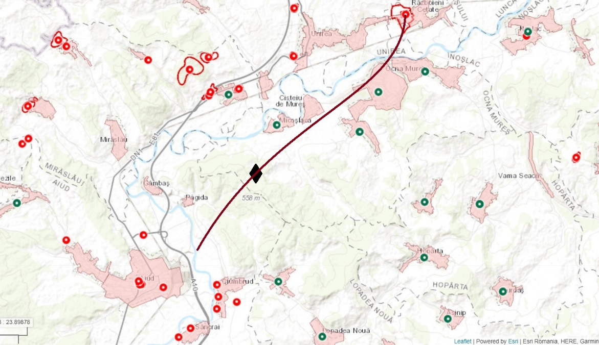
Fig. 9. The hypothetical secondary Roman road connecting Războieni-Cetate Roman fort, Salinae and Brucla. The black rhomb is the exact findspot of military diploma
(source: map.cimec.ro/Mapserver/)

ACKNOWLEDGEMENTS
We express here our gratitude to Mr. Csaba Kolosvari, directly involved in gather the information regarding many aspects of the discovery. We thank him also for providing us with references and information on various aspects regarding the site on the Micoșlaca village.
We are grateful to our colleague and friend, Călin Șuteu (Gigapixel Art S.R.L), who helped us in the photographic documentation of the artefact.
We are grateful to our colleague and friend, Cosmin Mihail Coatu, who have translated into English an important part of this paper.

REFERENCES

AE - L’Année Épigraphique. Revue des publications épigraphiques à l'antiquité romaine, Paris, 1888-
CIL XVI – H. Nesselhauf, Corpus inscriptionum Latinarum. Diplomata militaria, Berlin, 1936-1955.
IDR I – I. I. Russu, Inscripțiile Daciei romane. I. Introducere istorică și epigrafică. Diplomele militare. Tăblițele cerate, Bucharest, 1975.
RepAlba – V. Moga, H. Ciugudean (eds), Repertoriul arheologic al județului Alba, Alba Iulia, 1995 (Bibliotheca Musei Apulensis II).
RMD – M. M. Roxan, P. Holder, Roman Military Diplomas, I-V, London, 1978-2006.

BARBU/SIMION 2020
Barbu, M.G./Simion, M., Castrul Micia. 1. Stadiul cercetărilor. In: Forțiu, S. (ed.), In honorem Alexandru Rădulescu. Interdisciplinaritate în Arheologie și Istorie. Timișoara noiembrie 2020. Arheovest VIII₁ (Szeged: JATEPress Kiadó), 231-258.
BADEA et alii 1996
Badea, A./Căstăian, M./Coza, M./ Gligor, M./ Istrate, V./Petriş, D., Sondaje stratigrafice la Ciumbrud, Buletinul Cercurilor Științifice Studențești 2, 27-46.
CIUTĂ 2021
Ciută, M-M, Despre zonele arheologice protejate și modul de definire al acestora în România, Arheovest, IX_{1,} 87-122.
CIUTĂ, PURECE 2018
Ciută, M-M./Purece, S., Un tezaur de denari imperiali, recent descoperit la Micești, Studia Universitatis Cibiniensis. Series Historica 15, 25-36.
Ciută, Totoianu 2020
Ciută, M-M./Totoianu, R., A Flanged Axe discovered at Petrești-Dealul Netotu (Alba county), and some Remarks about Detectorists, Journal of Ancient History and Archaeology 7, 3, 64-73.
KIENAST/ECK/HEIL
Kienast, D./Eck, W./Heil, M., Römische Kaisertabelle. Grundzüge einer römischen Kaiserchronologie. 6., überarbeitete Auflage (Darmstadt: Wissenschaftliche Buchgesselschaft).
Lőrincz 1983
Lőrincz, B., Zur Konsulliste des Jahres 156, Zeitschrift für Papyrologie und Epigraphik 52, 211-212.
Macrea, Crișan 1964
Macrea, M./ Crișan, I. H. Două decenii de cercetări arheologice şi studii de istorie veche la Cluj (1944-1964), AMN 1, 307-365.
MATEI-POPESCU 2021
Matei-Popescu, F., Auxiliary Units from European Provinces in the Moorish War of Antoninus Pius. In: Cristea, Ș.,/Timoc, C./De Sena, E.C., Africa, Egypt and the Danubian Provinces of the Roman Empire. Population, Military and Religious Interactions (2nd-3rd centuries AD) (Oxford: BAR S3010), 5-16.
MISCHKA/RUBEL/VARGA 2018
Mischka, C./Rubel, A./Varga, R., Das Lager der ala I Batavorum milliaria und sein vicus in Războieni-Cetate (jud. Alba/RO), Archäologisches Korrespondenzblatt 48, 3, 377-405. DOI: https://doi.org/10.11588/ak.2018.3.75234
PETOLESCU 2021
Petolescu, C.C., Armata romană din Dacia (Bucharest: Editura Academiei Românie).
PISO 1993
Piso, I., Fasti provinciae Daciae I. Die senatorischen Amtsträger (Bonn: Rudolf Habelt Verlag).
POPOVICI/VARGA 2010
Popovici, P./Varga, R., Ad Vatabos: monografie arheologică a localităţii Războieni-Cetate (Cluj-Napoca: Editura Mega).
Szabó 2019
Szabó, G. V., Bronze Age Treasures in Hungary. The Quest for Buried Weapons, Tools and Jewellery (Budapest: Archaeolingua).
Teodor et alii 2014
Teodor, E.S./Borangic, C./Georgescu, R.M./ Josanu, V./ Lupu, E./Marcu, M./Simion, M./Ștefan, D./Suciu, C./Vizauer, I., Propuneri de reglementare a activităţilor de căutare a metalelor de interes patrimonial., https://www.academia.edu/84387711/PROPUNERI_DE_REGLEMENTARE_A_ACTIVIT%C4%82%C5%A2ILOR_DE_C%C4%82UTARE_A_METALELOR_DE_INTERES_PATRIMONIAL
TUDOR 1968
Tudor, D., Orașe, tîrguri și sate în Dacia romană. (Bucharest: Editura Științifică).
WOLLMANN 1996.
Wolmann, V., Mineritul metalifer, extragerea sării și carierele de piatră în Dacia romană / Der Erzbergbau, die Salzgewinnung und die Steinbrüche im römischen Dakien (Cluj-Napoca/Klausenburg: Muzeul Național de Istorie a Transilvaniei).

We refer, of course, to the Government Emergency Ordinance 43/2000 On the protection of the archaeological heritage and the declaration of archaeological sites as areas of national interest, a normative act that aimed to also regulate the use of metal detectors within archaeological sites. This act deals only with issues related to the manner of acquiring these devices, the authorization of its use within archaeological sites (exclusively by archaeologists authorized by the Ministry of Culture), the specification of the criminal character of the act of access with the metal detector in areas with archaeological heritage, in the absence of an authorization (issued by the Ministry of Culture). The same normative act anticipated the creation of a National Archaeological Repertoire, of a public character, containing all known archaeological sites, identified by different ways and methods, at the scale of the entire territory invoked, so that the owners of metal detectors that are not enrolled in the Romanian Registry of Archaeologists, be able to easily identify perimeters where they should not use the metal detector (CIUTĂ 2021).
The first attempts to initiate contact between museums and detectorists date back to 2006. They were followed by the attempt made by a team of archaeologists and lawyers to correct the legal provisions, through a document that came as an addition to the petition “National Historical Heritage between Professionalism and Amateurism” (TEODOR et alii 2014), later the Instruction no. 2 of the Minister of Culture from 2016 was issued, culminating in the bill Pl-x. 81/2018 to amend and supplement the Government Emergency Ordinance No.43/2000. We note however the constant lack of interest from those factors responsible, in accordance with the law, to issue, even in the absence of concrete clarifications in the text of the law, some methodologies, standardized procedures or some best practice manuals, to meet the need, which is real in most cases, to know which are the steps to follow in case of the chance discovery of any archaeological contexts. The situation is totally different than in other EU states, where the problem has been handled with professionalism (see for example the case of Hungary in Szabó 2019).
The Government Emergency Ordinance 43/2000 mentions in art. 4 (4) that random archaeological finds shall be announced, within 72 hours at the latest, to the mayor of the administrative-territorial unit by the discoverer, the owner or the holder of the right to administer the land in question, and at art. 10: Movable property resulting from random archaeological finds will be handed over by the discoverer, within a maximum of 72 hours, to the decentralized public services of the Ministry of Culture and Cults, while the law 182/2000 provides, in art. 49 (1) the fact that Private persons who accidentally discovered goods from the category of those mentioned in art. 46 para. (1) are obliged to hand them over, within 72 hours from the discovery, to the mayor of ATU in whose radius the discovery was made; (2) The mayor is obliged to notify the decentralized public service of the Ministry of culture, within 72 hours, about the discovered goods, while taking measures to guard and preserve them; (3) the mayor is obliged to hand over the goods thus discovered, within 10 days, to the decentralized public service of the Ministry of Culture.
The total number of licensed metal detector holders nationwide is estimated to have exceeded 7000 (May 2022). If we add to these the estimated number of those who own metal detectors but have not authorized themselves, it is very likely that the total number passes 14.000!
As a result of the awareness of the paradoxical situation which was reached in the absence of regulation, to avoid a series of potential situations that would lead to the impairment (loss) of the cultural heritage of archaeological provenance, the Alba county Police Department conceived a synthesized methodology in the form of a minimal training called “Best Practices”, which is communicated to the applicant for the authorization to possess the metal detector, being brought to attention a series of essential elements: the legal basis, the legal sanctions in case of misbehaviour, the sources of documentation regarding the legal protection of the archaeological areas, rules to be observed when discovering cultural goods, the institutions to which the discovered goods are handed over, the contacts of these institutions (telephone, email, etc.). We do not know which is the situation in the other 40 counties in the country, respectively in Bucharest, but it is hard to believe that the people and institutions with responsibilities to the national cultural heritage within the Romanian police force - who have many other duties - have the necessary time and qualification to carry out such training.
Mr Kolosvari Csaba, an authorized metal detector owner since 2021, previously stood out by reporting the discoveries made in the hinterland of Ocna Mureș (and neighboring localities) and handing them, in full legal conditions, to the mayors of the related administrative territorial units.
There have been similar situations in which, for objective reasons, in order to comply with the legal provisions of 72 hours allocated for surrendering the artefacts likely to belong to the cultural heritage, were taken over in this way (e.g. Ciută/Purece 2018; Ciută/Totoianu 2020).
Coordinates: 46º21'18,7”N and 23º47'09,6”E. The operation was carried out at the headquarters of the Alba County Police Inspectorate, on the 29th of March 2022. Although the conservation status of the piece was a good one (being made of good quality copper), it was subjected to primary conservation procedures, being later handed over to the Aiud History Museum.
RepAlba 1995, 127; Macrea/Crișan 1964, 319, 357 (Cisteiu de Mureş commune, Aiud district). A copper ax with a cross-cut was discovered in the village’s forest, (Pădurea Dosu) Eneolithic (RepAlba 1995, 127).
Macrea, Crișan 1964, 357 (Cisteiu de Mureş commune, Aiud district).
Information provided by I. Mitofan in Romania’s Archaeological Gazetteer.
TUDOR 1968, 205-208; WOLLMANN 1996, 241-242.
KIENAST/ECK/HEIL 2017, 128-129.
Petolescu 2021, 169-170, no. 12.
Petolescu 2021, 206-209, no. 33.
Petolescu 2021, 266-267, no. 74.
CIL XVI 108 = IDR I DiplD 16, given to Heptapor Isi f., Bessus, a former horseman of the ala I Gallorum et Bosporanorum, accommodated within the Cristești Roman fort (Petolescu 2021, 159-161, no. 5). Since the diploma was found there, it is obvious that the veteran lived in the military vicus of that large fort.
RMD I 35, Dacia Porolissensis, the 2nd of July, 133. Another constitution for the auxiliary soldiers of the Dacia superior province was issued on the 13th of December, 156, attested by a fragmentary diploma discovered in 1851 at Tibiscum (Jupa, Caransebeș, Caraș-Severin county), releasing thus from duty the veterans who had been enrolled in AD 131 (CIL XVI 107 = IDR I DiplD 15; for the year see the M. M. Roxan in RMD III, p. 246, no. 51*107, following B. Lőrincz’s suggestion (Lőrincz 1983), already mentioned in RMD II, p. 132, no. 67*107, that the consuls Q. Canusius Praesentinus and C. Lusius Sparsus held their position in the last nundium of the year 156). The copy was given to a former foot soldier of the cohors I Vindelicorum milliaria, Barsimsus Callistenis f. from Caesarea, who served exactly at Tibiscum where his unit was accommodated. Another copy of the same constitution could be the fragment also discovered at Tibiscum, during the archaeological excavations of the 1978 season, given to a former foot soldier from Chalcis, thus of Eastern origin, too, and probably serving within the same unit (RMD II 122). Both soldiers would have been recruited while the units would have taken part in the suppression of the Jewish Revolt of AD 132-135.
AE 1993, 1577 = AE 1996, 1540 = IDRE II 411; POPOVICI/VARGA 2010; MISCHKA/RUBEL/VARGA 2018.
For unit see Petolescu 2021, 157-159, no. 4.
PISO 1993, 166-173, no. 16.
PETOLESCU 2021, 244-245, no. 59, unknown fort.
PETOLESCU 2021, 232-234, no. 48, accommodated in the Inlăceni fort.
PETOLESCU 2021, 234-236, no. 50, unknown fort.
PETOLESCU 2021, 260-264. See also MATEI-POPESCU 2021.
CIL XVI 107 = IDR I DiplD 15, a fragmentary diploma discovered in 1851 at Tibiscum (Jupa, Caransebeș, Caraș-Severin county); for the year see the M. M. Roxan in RMD III, p. 246, no. 51*107, following B. Lőrincz’s suggestion (Lőrincz 1983), already mentioned in RMD II, p. 132, no. 67*107, that the consuls Q. Canusius Praesentinus and C. Lusius Sparsus held their position in the last nundium of the year 156). The copy was given to a former foot soldier of the cohors I Vindelicorum milliaria, Barsimsus Callistenis f. from Caesarea, who served exactly at Tibiscum where his unit was accommodated. Another copy of the same constitution could be the fragment also discovered at Tibiscum, during the archaeological excavations of the 1978 season, given to a former foot soldier from Chalcis, thus of Eastern origin, too, and probably serving within the same unit (RMD II 122). Both soldiers would have been recruited while the units would have taken part in the suppression of the Jewish Revolt of AD 132-135. For the unit see PETOLESCU 2021, 248-251, no. 63.
PETOLESCU 2021, 247-248, no. 62, accommodated in the Odorheiul Secuiesc fort.
PETOLESCU 2021, 222-224, no. 43, accommodated in the Pojejena fort.
PETOLESCU 2021, 254-256, no. 66, accommodated in the Cigmău fort, not far from Germisara (Geoagiu Băi).
The witnesses are known to have signed the diplomas in this order between the 13th of December, 156 and the 18th of December, 160 (see e. g. RGZM 37, on the 23rd of April, 157, and RMD V 420, on the 27th of February, 158), with the exception of C. Pomponius Statianus, who is last attested by the diploma from Cristești (CIL XVI 108 = IDR DiplD 16), and replaced by P. Graecinus Crescens (RMD V 424, the 21st of June, 159; RGZM 39, 7th of February, 160; RGZM 41m 7th of March, 160; ), but returned on the 8th of February, 161 on the seventh place (RMD V 430 = RGZM 43). The lists of the witnesses were lately compiled by P. Holder in RMD V, Appendix IIIa..
Fragments of a ceramic pot, dating to 2nd-3rd century AD were discovered on the Măgura Hill (RepAlba 1995, 139).
In the location at “La Ic”, situated on the way to Păgida, North of the village, archaeological investigations carried out in 1968 led to the identification of a Roman settlement. In the location “Podireu”, situated South of the village, to Sâncrai, on the first terrace of the Mureș river, another Roman settlement has been noticed. In the location “La Cioca”, archaeological investigations carried out in 1968 led to the discovery of ceramic fragments (terra sigilata) and a bronze needle (RepAlba 1995, 79-80). In 1995, archaeological investigations carried out by a team of the “1 Decembrie 1918” University of Alba Iulia, led by M-M. Ciută, uncovered a rich lot of Roman ceramic materials (BADEA et alii 1996, 27-46).
Traces of a Roman settlement were noticed in the courtyard of the Banffy Castle and on the entire surface of the village. Roman artefacts were discovered in various unknown locations, among which the base of a limestone funerary monument with the representation of the signum originis, now in the collections of the National Museum for the History of Romania, needs to be mentioned here (RepAlba 1995, 174-175).
RepAlba 1995, 20-27.
CIL XVI 33 = IDR I DiplD 24, 13th of May, 86, for the army of Iudaea province; see also RepAlba 1995, 23, 26.
Including some 20th century infrastructure elements, such as high voltage lines. The topographical maps highlight, through contour lines, this reality in the field (see. Fig. 9).

