Aerial archaeology in Romania. Sites from Roman Dacia examined using aerial photos

Gabriel Emanuel Rus
University ‘Babeş-Bolyai’ of Cluj-Napoca
rusgabriel23@gmail.com

Keywords: aerial archaeology, aerial archaeology investigations in Romania, pioneers, programs and projects, archaeological sites in Roman Dacia analyzed using aerial photographs
Abstract: The history of aerial archaeology in Romania is strictly linked to the political history of the state represented by the regimes and bureaucracy systems. The importance of this domain was only acknowledged in Romania after 1989 when important programs were unrolled, in particular those for the sites belonging to the Roman period in Dacia’s area.

Aerial archaeology was discovered long ago and even before the first cameras, some of the oldest mentions of this method dating from the 17th century when people from Italy and Britain saw changes in the shades of their crops. This happened in the ripening season, with some of the plants growing well while others presenting pale or yellower colors. It was then discovered that beneath those yellower plants which did not had enough water to grow healthy were sitting antique monuments from the Roman times.
This method of investigating marks in the crop fields, other types of vegetation or simply on the ground is still applied today but with the help of new technology. Aerial archaeology focuses on analyzing photographs made from high altitudes to find new possible traces of historical monuments, to analyze those already knew or to observe the conservation state of the structures. If the monuments are located underground and the photos are made by a specialist they should appear on the images as marks(Fig. 1). Those could be shadow-marks, crop marks, soil marks, frost and snow marks, or damp marks, their apparition being influenced by geographical and climate factors.
Some countries like France and Great Britain experienced a stable development of this approach which studies historical monuments, which is due to many factors such as geographical conditions, military techniques or the liberty guaranteed by their political regimes.
In Romania’s history aerial photography welcomed many obstacles in the way of creating systematically programs for archaeology purposes, many due to the ex-political authorities. The situation is still not clear today, as this domain is facing lack of funds and specialists, carelessness, destructive methods being preferred instead of those nondestructive, like aerial photography.
Through the first activities which implied aerial photography and were documented in Romania we find those of Carl Schuchhardt. In 1918, March, during the First World War, Carl S. started a number of aerial prospections, investigating the roman limes in the area of Danube and Black Sea, the photos being published in 1954.
Other research was done back in 1931 for the roman fort at Argamum, done by Paul Nicorescu, and in 1938 at Histria(Fig. 2), supervised by Scarlat Lambrino who fled some years later to Portugal because of the communist regime which was installing in Romania.
Dinu Adameșteanu was also a pioneer in the field of aerial photography, fleeing in 1939 to Italy and doing his research there. He revisited his native country in 1968, and many years after, with the purpose of highlighting the importance of aerial photography, offering scholarships for the interested students. He also tried to create an archive for photographs in Romania, using the model he applied in Italy.
From the first collaborations with Dinu Adameșteanu we can find those of Ioana Bogdan-Cătăniciu, who studied starting with 1969 areas in Muntenia, Troesmis, Adamclisi, Colonia Aurelia Apulum, using aerial photographs.
Another step for the Romanian archaeologists collaboration with experts from other countries took place in 1975, Bucharest, when Irwin Schollar held an exposition about aerial archaeology in Rhine Valley.
A special department was created in Romania in 1978, called ‘Secția de cercetări aerofotografice și evidență centralizată a siturilor arheologice’ at Muzeul Național de Istorie a României. This was where the national archive of aerial photographs was moved, earlier being stored at Instutul de Arheologie from Bucharest. In the front of the department was Alexandru Simion Ștefan who promoted the usage of aerial photographs resulted from other activities such as cartography, in the field of archaeology, and also started a number of aerial prospections.
In the end of the ‘70s other aerial photography programs occurred, with the most of them made by Alexandru Simion Ștefan who collaborated with Institutul de Geodezie, Fotogrametrie, Cartografie și Organizarea Teritoriului (IGFCOT). Some of the investigations were made for areas at Munții Orăștiei, the Danube line, Iron Gates II, with the results being published not only in Romania, but also outside.
A public institution from Romania, named Consiliul Culturii și Educației Socialiste (CCES, currently named Institutul de Memorie Culturală, CIMEC), also played an important role in this domain because it was hosting collections of topography archaeology documents, which will be used later in different researches by archaeologists.
So far we can see a period where collaboration within institutions and researches was flourishing, and also a big number of aerial prospections being started. But this only lasted until 1984, when the legislation of the communist regime made practically impossible to make this kind of prospections. Another effect of those changes was that Alexandru Simion Ștefan fled to France in 1986, and no other aerial prospections were made until 1989-1990.
But even after the democratic regime was installed, the legislation problems still existed, being inherited from the ex-communist regime. Civil flights required special authorizations, in many zones those activities being forbidden, and also there was a big lack of funding for this domain. The alternative for archaeologists to study aerial photographs could have been the using of topographic maps, but those collections were included in the top secret documents, most of them being made by the army. About the national archive of aerial photographs made for archaeological purposes, this was closed to public, and being in a bad conservation shape.
Only two aerial photography actions took place in the beginning of the ‘90s, but mostly for advertising reasons. The first one was made by E. Pescaru, with the help of a helicopter, for different sites in Hunedoara, and the other one being made by V. Barbuta, which photographs helped in the discovery of the Liber Pater temple from Apulum after cropmarks analyses.
The most important program of aerial archaeological investigation begun in 1998. This was the result of the collaboration between different institutions, like Muzeul Național de Istorie al Transilvaniei din Cluj, Universitatea de la Alba Iulia și Muzeul Civilizației Dacice și Romane Deva with the University from Glasgow. This program was initiated by Ioana Oltean and W. S. Hanson from University of Glasgow, and funded by Leverhulme Trust and the British Academy, with the main objective to start a number of systematic flights of aerial photography.
The program focused on the late Iron Age and the Roman period, in the South and Vest of Transylvania, with the flights taking place between 1998 and 2004, counting 30 hours of aerial photography every year. Among the investigated objectives there are the vici from Micia and Cigmău, other constructions at Apulum, villae rusticae from Oarda and Vințu de Jos, and other settlements dating from the Iron or Medieval Ages. The results were published in Ioana Oltean’s book in 2007, Dacia, Landscape, Colonisation, Romanisation. The author, with an important place in Romania’s aerial archaeology researchers, attended at the courses of Aerial Archaeology Research Group (AARG) in Hungary. This organization started its activity with 1996 in ex-communist states in Europe, willing to teach students and other persons about the research done by aerial archaeology. AARG was created in 1981 in Great Britain and is known for its involvement in promoting aerial prospections and international annual conferences about this subject.
Moving on to another structure, Institutul de Memorie Culturală will have an important role in supporting aerial prospections in Romania. The institute is managing national databases like Repertoriul Arheologic Național, digital archives and the central file of the cultural patrimony.
In 1991 CIMEC introduced a list of archaeological sites and historical monuments (list which came from Direcția Monumentelor, Ansamblurilor și Siturilor Istorice) in RAN’s database. Doing so, the personnel encountered a problem raised by the lack of information this list provided. The problem refers to the locations of those sites because only 20% of them had precise geographical coordinates. Among the solutions found there was aerial archaeology, but in Romania there were not enough specialists in this domain. They had to collaborate with foreign experts to teach and instruct Romanian archaeologists in analyzing and using aerial photographs, for the purpose of identifying and mapping sites.
The collaboration started with a project called Peisaje europene:trecut, prezent și viitor inside the programme Cultura 2000, between 2004 and 2007. In 2005 was held the first international course of this program at Bușteni with 34 participants, six of them being CIMEC’s employees. The members were taught about the interpretation of aerial photographs and how to put them to use for the archaeology domain.
The pilot project of aerial prospection in Romania was chosen to be an area surrounding Mostiștea river. This decision was influenced by many factors like the vicinity an airport at Cliceni, the good relations between the archaeologists in this zone and the researchers, and also by the interest to apply this method in an area where there is a lack of stone buildings. The target of the project was to obtain exact geographical positions of known or newly discovered archaeological sites. This was done with the new flights but also by analyzing older aerial photographs which were made for other purposes, in order to see the changes of the landscape.
The flights where initiated in July 2007 using a Cessna plane, a Canon camera and GPS’s. In 2007 other aerial prospections were made by Carmen Bem at Valea Neajlovului in Bucșani area, during which new settlements were discovered dating from the Bronze Age or Iron Age.
In 2008, between May and June, Rog Palmer from Cambridge University studied using aerial prospections areas from Mostiștea, discovering traces of some graves and settlements like the ones from Preasna Veche. In 2009 and 2010 areas of the rivers Vedea and Teleorman were investigated, in the end 10 new Neolithic settlements being discovered.
Another important objective of the project was to examine Sultana area, more accurate the archaeological sites from here which dates from the Eneolithic. This was done by comparing new photos with older ones in order to see the condition of the site which was destroyed by erosions in proportion of 70%. All the results of those investigations were presented at Aerial Archaeological Research Group conference in 2010 at Bucharest.
Nowadays, aerial program taking place in Romania are few, with their results not always being accessible to the public. About the number of flights, some of the obstacles are the low number of experts, airports accessibility, lack of funds, the indifference of the officials or the lack of a public database of aerial archaeological photographs. It is easier now to buy ortophotoplans from structures like ANCPI than to start aerial prospections, but the ortophotoplans were not made for archaeological purposes, so the results won’t be great.
Among the prospections made during the recent years I would mention those done by Muzeul Județean Mureș in colaboration with Institutul de Arheologie și Istoria Artei al Academiei Române and Babeș-Bolyai University, the investigations at Porolissum, and the ones for Limes Transalutanus.
Participants of the first project were Sándor Berecki, Zoltán Czajlik and Simion Câmpeanu, who analyzed different areas in Transylvania in order to discover or detect historical structures dating from Prehistory to the Middle Ages. The results were published in 2012, and for the flights it was used an CTSW light plane with high wings.
At Porolissum it was used the LiDAR scanning because the area was highly wooded, aerial photography being useless for those zones. The prospections took place in 2013, with the photos being taken from an helicopter on an area of 10 km² and then analyzed using ArcGIS for a better understanding(Fig. 3).
The last and more recent project analyzes sections of the Limes Transalutanus, participants being researchers and members from Muzeul Național de Istorie a României, and Institutul de Arheologie Vasile Pârvan. The first phase of the project started in 2014 between 1 July and 5 December, analyzing a large area covering 155 km using aerial photographs, geophysical prospections, archaeological diggings and surface surveys, military ortophotoplans or images done by UAV’s.
After this short history about aerial archaeology in Romania I would like to point out a number of sites from Roman Dacia which were the subjects to this kind of investigation, in order to highlight the importance of this method and its results.
The area where the most aerial prospections were done in order to investigate roman castra is Dacia Superior, where we can find Micia(Vețel), Germisara(Cigmău) and Războieni-Cetate. Outside of those military positions there were found traces of civilian settlements or military vici, which are clearly connected to the castra.
At Micia the castrum measures 6.51 ha and archaeological diggings were made starting with 1929. Here were found baths with palaestra, a small amphitheater, houses with one them having hypocaustum, two graves located at the East and South of the castrum, and a temple dedicated to the gods of moors, the presence of the latter being confirmed by inscriptions found here. Other military units which were present here were ala I Hispanorum Campagonum and coh. II Flavia Commagenorum.
Aerial investigations were done at Micia, more exactly at the vicus, between 1998 and 2004, by Ioana Oltean and Bill Hanson. Cropmarks played an important role in the interpretation of the photos, being highly visible in the summer. Those marks could then help to establish the construction phases of the stone buildings found here(Fig. 4).
The stone structures which are visible on the photos are located near the ones already known, and they are stretching from the Vest side of the castrum on 850m. At a more detailed analysis the researchers found that the structures are probably the ends of four buildings and some interior roads.
While aerial investigation took place a problem was raised by the crops which grow in this area. Only in small portions there were plants like barley and wheat, plants which help at the formation of cropmarks, being highly dependent to humidity. The rest of the plants cultivated in the area play no role in the formation of those marks, mainly just obstructing the visibility of what is on the ground.
The castrum at Germisara located near the Mureș river is also surrounded by a military vicus, which plan was restored using aerial photographs. Again, with aerial photographs a roman road could be discovered, located South-Vest to the fort. The road was visible on the photographs on the form of cropmarks which appear along the both sides of the road’s ditches. The limits of the fort could also be established with this method, together with some defensive stone walls, an access gate or buildings inside the castrum like Principia or horreum.
The position of the civilian settlement at Cigmău was little known, and only with the help of surface archaeological activities. But the aerial photographs made in 2000 and 2002 solved this problem because some negative cropmarks visible on the photos made at the East side of the castrum may confirm the presence of some stone buildings, which could be part of the civilian settlement.
The position of the vicus at Războieni-Cetate was also established using aerial photographs made by Ioana Oltean and Bill Hanson. It is somewhere at 200m North the castrum and its expansion measures 750m in the East and West sides. The structures appear on the photos as cropmarks, also a complex system of roads being visible. The expansion of the settlement means that the vicus was well organized, with a high grade of development.
A comparison was made by Viorica Rusu-Bolindeț and Onofrei Cosmin between the plans of the castrum at Războieni-Cetate made by Ioana Oltean and the plans made by other authors in 1995 and 1996. The conclusions were that the real size of the castrum was probably the one established using aerial photographs, done by Ioana Oltean. The two authors also discuss the military vicus along the castrum, which had two habitation cores, one in the North and one in the South, visibile on the photographs.
Sections of the roman limes in Dacia are currently systematically analyzed using aerial archaeology since July 2014. In this case we refer to components of the Transalutan limes, south of Argeș river. Other research was done here in the past by Ioana Bogdan Cătăniciu, again using aerial photographs, but the results were not the ones expected. Carls Schuchardt also analyzed this limes, but his presumption was that defensive border was just a roman road.
This new project started a year ago follows new archaeological research technologies like geophysics, aerial photographs made by UAV’s, surface activities, GIS analyzes, the destructive methods being ignored.
The target area for the research represents an opportunity for aerial prospections because archaeological traces are almost invisible from the ground. The dyke along the limes, which is in a badly preserved shape, can be seen on the photographs as straight lines stretching to North-East and South-Vest.
The photos used for this project are mostly oblique, made from light planes or drones, but also vertical photos like ortophotoplans coming from other institutions.
Following the defensive ditch only partially visible on the ortophotoplans, the researchers from the project succeeded to make the structure more visible on the images, using photogrammetry algorithms which could penetrate the dense layers of tall plants in the area.
Another kind of structures, which were little investigated in the area of Roman Dacia using any kind of archaeological methods, are the villae rusticae. They did not got too much of attention from historians or archaeologists because of many reasons. Some of them could be the strategic position Dacia had for the Roman Empire, position expressed by the big number of military settings. The same problem applies for the rural settlements in Roman Dacia.
There is submitted a number of 100 of villae rusticae, but only 25-30 of them present a higher grade of veracity. Those type of farming settlements consist of a house located in the center, where the owner sits, the settlement being surrounded by walls and along those, in the interior, there are other buildings like the slaves house, warehouses, barns or watchtowers.
The locations of villae rusticae are mostly near the roads or other communication routes and in Roman Dacia we have different types of those constructions: farms witch an intensive agriculture due to the geographical factors (Miercurea,Caransebeș), farms along the main roads(Aiton,Șura Mică), and farms near big cities(Hobița,Sântămăria Orlea).
In the course of the project Aerial Reconnaissance of Western Transylvania there were analyzed, alongside with other possible villae rusticae, the settlements from Oarda, Șibot and Vințu de Jos. Eventually those settlements were then excavated archaeologically and confirmed to be villae rusticae. In those three cases the structures were visible on the photos as plough marks and they were made of stone. At Oarda there were identified traces of some buildings grouped around a central yard in the form of negative cropmarks which appeared in the barley crops(Fig. 5). At Șibot and Vințu de Jos there were also seen remains of some structures on the aerial photographs.
Other structures were investigated with aerial archaeology for sites in Roman Dacia, such as extraction quarries, graves and roads.
In Dacia’s area the Romans benefited by the rich deposits of metals, salt or stone. The most known place where extraction activities took place was at Alburnus Maior, but also in other areas, such as Pianu de Sus, which was investigated using aerial archaeology. The photographs revealed marks of extraction activities, gold being probably the one Romans were looking for here.
Searching information using aerial photographs for the archaeological landscape at Micia’s vicus, the researchers found here a circular structure located in the interior of the settlement. The results concluded that this was probably a center for the pottery production.
Not much information about the graves found at Vințu de Jos with the help of aerial archaeology, only that they contain most probably cremated remains and there are no stone constructions.
Parts of the roman roads in Dacia were also discovered at Bobâlna, Sebeș, Micia, Apulum, Cigmău and Alba Iulia, the last two appearing on satellite images.
All things considered, there can be seen a progress in aerial archaeology domain in Romania after 1989 with more projects being developed, but there is still more work to do, as in this state there are numerous archaeology sites, known or newly discovered, with many of them lacking exactly geographical coordinates, limits and plans, or a better way to monitor their preservation state.

References
BERECKI/CZAJILIK 2012
BERECKI, SÁNDOR, CZAJILIK, ZOLTÁN, Panorame istorice, Târgu Mureș, L’Harmattan/Mega, 2012.

BOLINDEȚ/ONOFREI 2010
RUSU-BOLINDEȚ, VIORICA, ONOFREI, COSMIN, Date noi privind activitatea militară și cultura materială a alei I Batavorum de la Războieni-Cetate. In: Rusu Bolindeț-Viorica/Sălăgean Tudor/Rada Varga(eds.): Studia Archaeologica et Historica in honorem magistri Dorin Alicu, Cluj-Napoca, Argonaut, 2010.

GUDEA 2008
GUDEA, NICOLAE, Așezări rurale în Dacia romană, Oradea, Primus, 2008.

MUSSON/PALMER/CAMPANA 2013
MUSSON, CHRIS, PALMER, ROG, CAMPANA, STEFANO, Flights into the past: aerial photography, photo interpretation and mapping for archaeology, Aerial Archaeological Research Group/ Arcland,2013.

OBERLÄNDER 2010
TÂRNOVEANU-OBERLÄNDER, România: Un viitor pentru trecut. Fotografiile aeriene în repertorierea siturilor arheologice (Raport final la Proiectul ‘Peisaje europene: trecut prezent și viitor), CIMEC.
OLTEAN 2007
OLTEAN, I., Dacia: Landscape, colonisation, romanisation, Routledge, 2007.

OPREANU/LĂZĂRESCU 2014
OPREANU, HORAȚIU CORIOLAN, LĂZĂRESCU, VLAD ANDREI et al., ‘New light on a roman fort based on a LiDAR survey in the forested Lanscape from Porolissvm’. In: Opreanu Coriolan Horațiu (ed.): Ephemeris Napocensis XXIV, Cluj-Napoca, Mega Print, 2014.

PALMER/TÂRNOVEANU/BEM 2009
PALMER, ROG, OBERLÄNDER-TÂRNOVEANU, IRINA, BEM, CARMEN, Arheologie aeriană în România și în Europa, București, CIMEC, 2009.

TEODOR/ȘTEFAN 2014
TEODOR, Eugen S., Ștefan, Magdalea, Landscape archaeology along Limes Transalutanus. In: Găzdac Cristian (ed.): Journal of Ancient History and Archaeology, vol. 1, nr. 3, Cluj-Napoca, 2014.

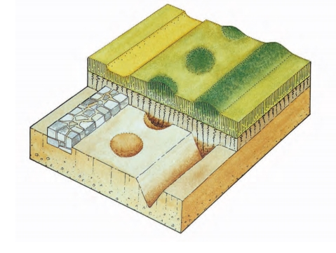
Fig.1. Formation of positive(above a ditch) and negative (above the stone wall) cropmarks. (
MUSSON/PALMER/CAMPANA 2013, 67, fig. 2.7)

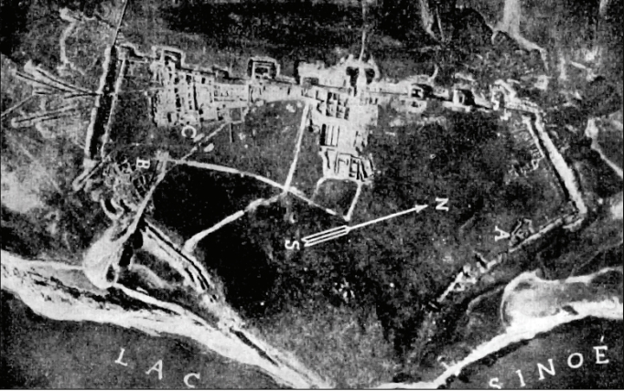
Fig. 2. The Roman-Byzantine fort at Histria.( PALMER/TÂRNOVEANU/BEM 2009, 63, fig. 1).
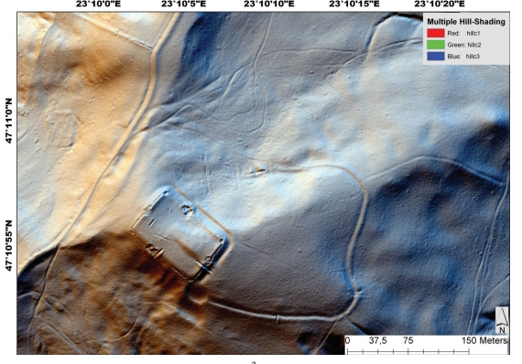
Fig.3. LiDAR investigation at Porolissum castrum. (OPREANU/LĂZĂRESCU 2014, 79, fig. a)

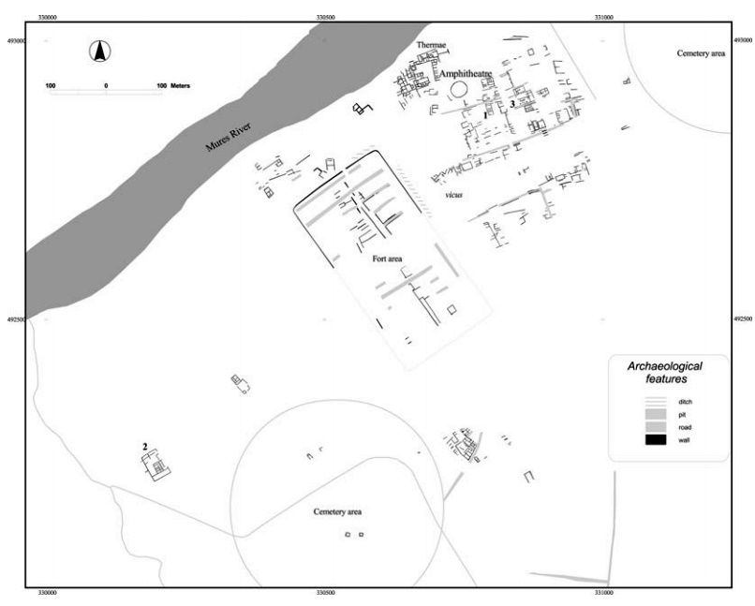
Fig. 4. Plan of the castrum and the vicus at Micia. (OLTEAN 2007, 157, fig. 5.28).
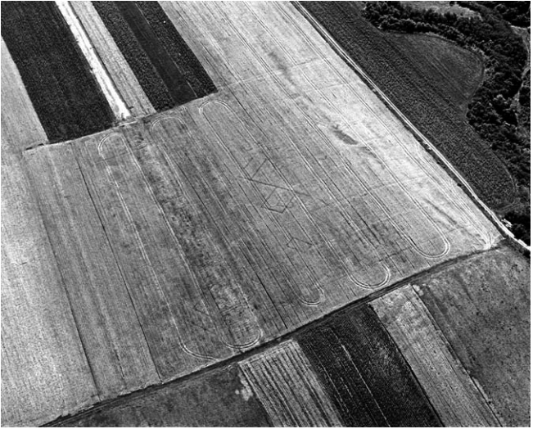
Fig. 5. Vertical photograph showing traces of the Roman farm at Oarda. (OLTEAN 2007, 129, 5.9)

MUSSON/PLAMER/CAMPANA 2013, 17.
PALMER/TÂRNOVEANU/BEM 2009, 64.
Ibidem.
OBERLÄNDER 2010, 389.
OBERLÄNDER, 2010, 389.
OLTEAN 2007, 14.
PALMER/TÂRNOVEANU/BEM 2009, 66.
BERECKI/CZAJILIK 2012, 8.
OBERLÄNDER 2010, 393.
MUSSON/PLAMER/CAMPANA 2013, 52.
BERECKI/CZAJILIK 2012, 9.
OPREANU/LĂZĂRESCU 2014, 71-73.
TEODOR/ȘTEFAN 2014, 31.
OLTEAN 2007, 155.
OLTEAN 2007, 156.
OLTEAN 2007, 156.
OLTEAN 2007, 158.
OLTEAN 2007, 158-159.
BOLINDEȚ/ONOFREI 2010, 402-403.
TEODOR/ȘTEFAN 2014, 34.
TEODOR/ȘTEFAN 2014, 34.
TEODOR/ȘTEFAN 2014, 35.
TEODOR/ȘTEFAN 2014, 35.
GUDEA 2008, 37.
OLTEAN 2007, 126.
OLTEAN 2007, 126.
OLTEAN 2007, 183.
OLTEAN 2007, 185.
OLTEAN 2007, 192.
OLTEAN 2007, 195.

